AUTHOR COMPONENT

**1.Create an author component**

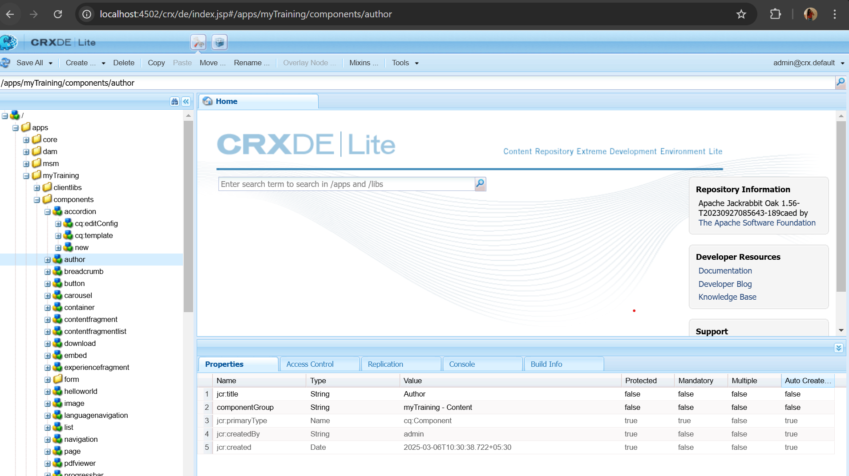

Create nodes for author name,author bio and dob.

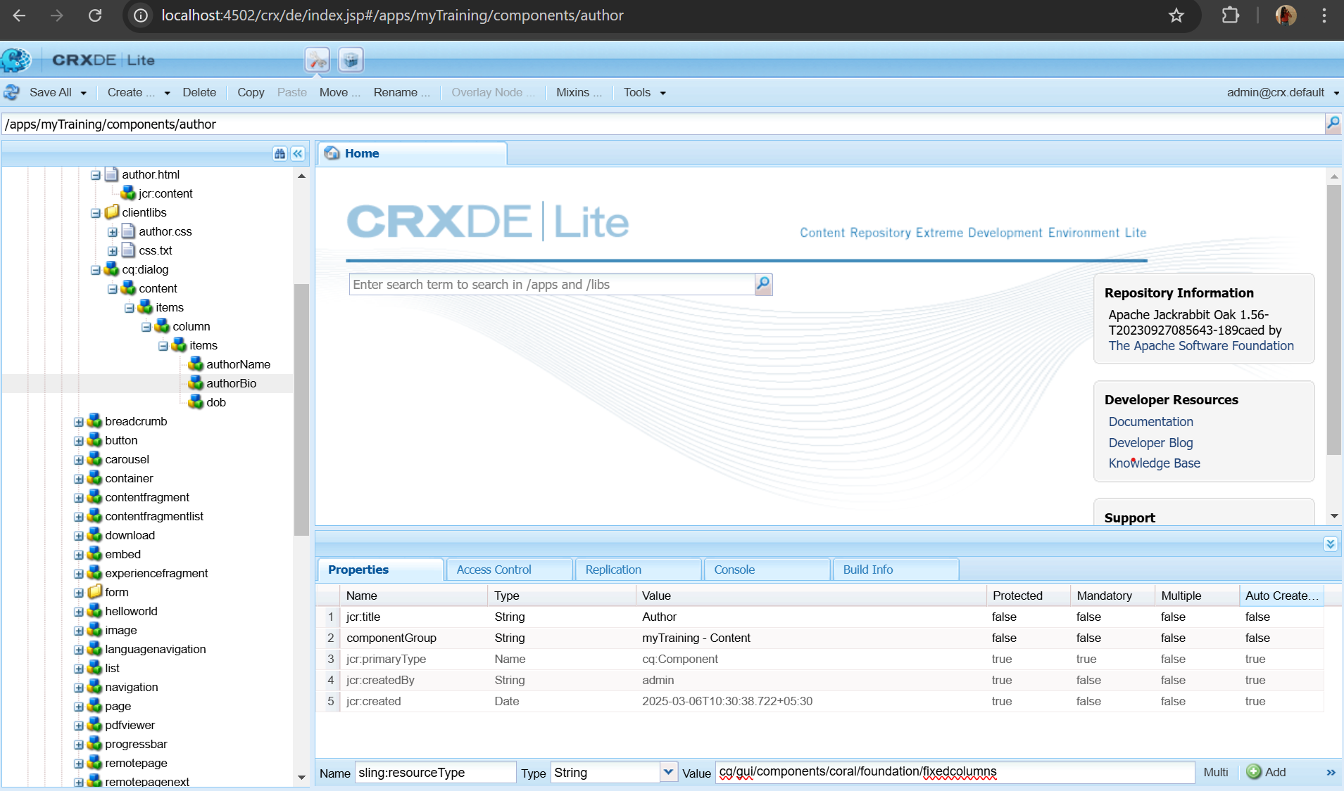

**2.Adding Properties**

Author Name Properties:

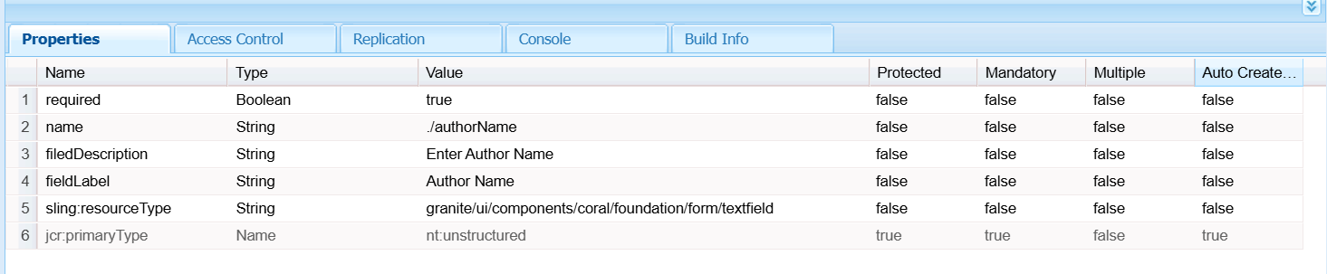

Author Bio Properties

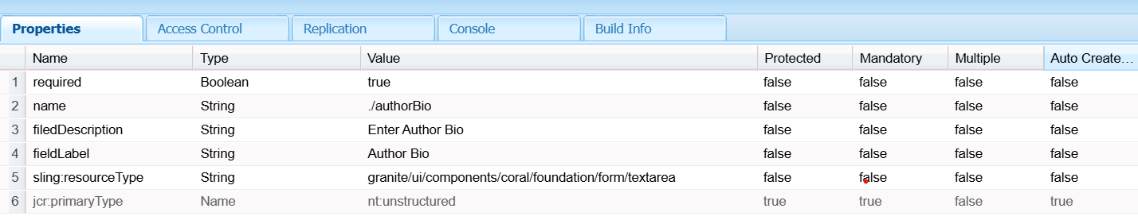

DOB properties

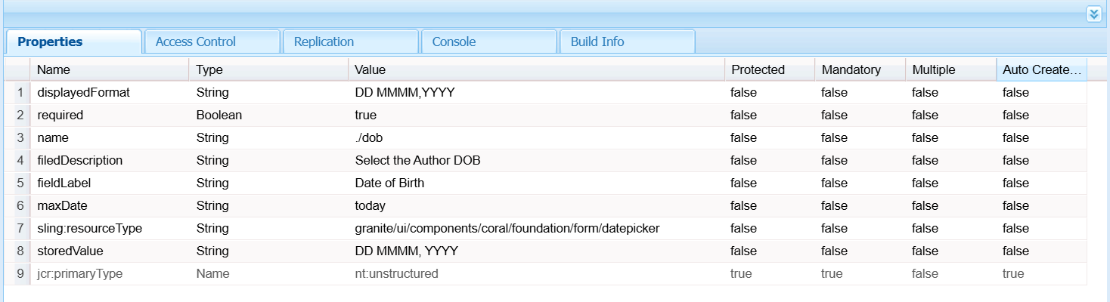

**3.Fetching Properties using HTL**

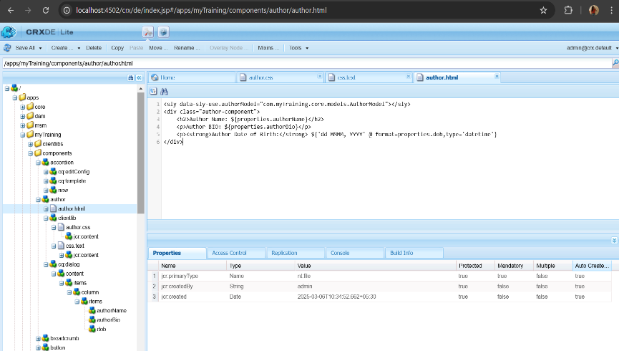

OUTPUT:

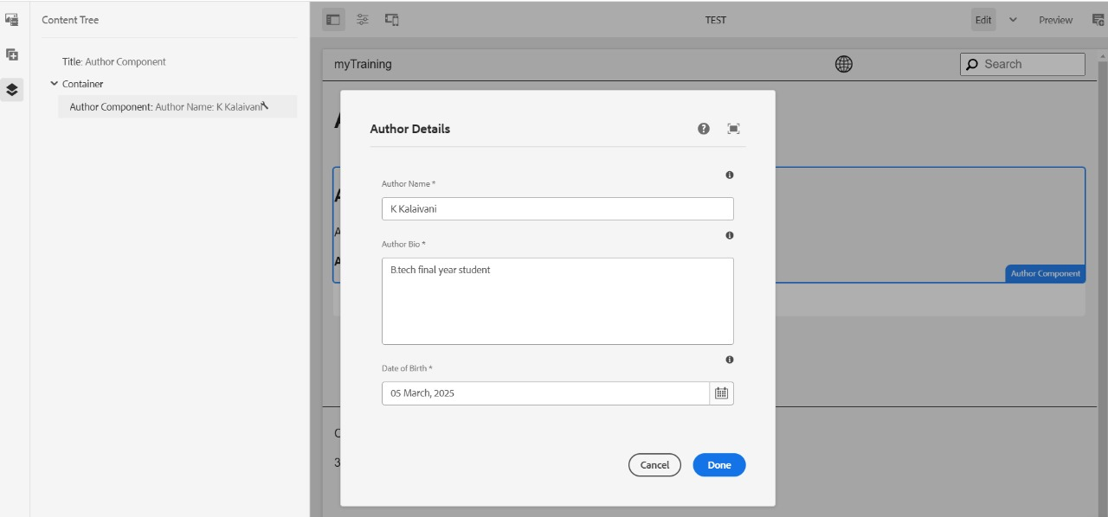

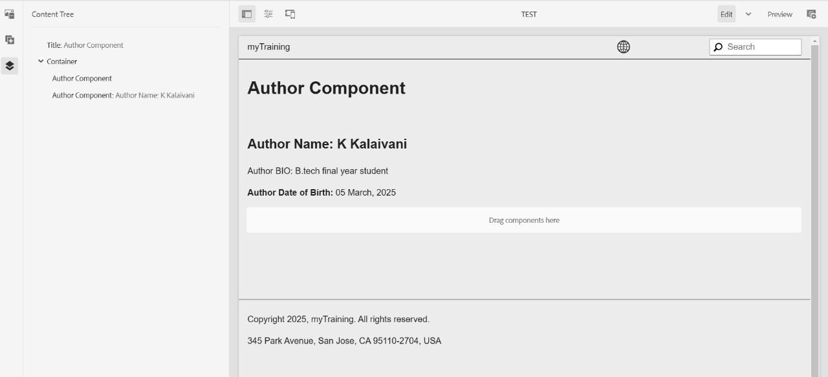

**4.What is Dialog Validation?**

Dialog validation ensures that required fields must be filled before saving the component.

* validation="[foundation.validation.mandatory]" ensures users cannot save the dialog unless the field is filled.
* For custom validation, you can write a client-side validation script in clientlibs.

**5.What is a ClientLib?**

ClientLibs (Client-Side Libraries) in AEM are used to manage **CSS, JavaScript, and other assets** efficiently.

* They help load styles and scripts only when needed.
* They are defined in /apps/<your-project>/clientlibs.

**6.What is extraClientLibs?**

* **extraClientLibs** is an AEM feature that allows adding additional client libraries from **within a component**.
* Used inside the cq:dialog to load specific libraries for a dialog.